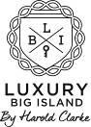

STATUS REPORT | FEBRUARY 2017


Activities & Results

Goal I: Solidify Harold Clarke’s position as the “go to” broker for buying and selling luxury real estate on the Big Island
- Drafted press release on Kukio MB23; distributed via PR Web for SEO purposes
- Utilized the Kukio MB 23 press release as a tool for broader pitching on topics including:
  - The state of the market in Kukio/the Big Island (Representative media targets included: local print, digital and broadcast;Associated Press; Forbes.com; Bloomberg Pursuits;The Financial Times)
  - The unique design of the home (Representative media targets included: Los Angeles Times - Hot
Properties;Architectural Digest, Luxury travel publications)
- Researched and outreached to entrepreneurial publications and writers for pitch surrounding Harold Clarke’s unique story and outlook on life and business (Representative media targets: Entrepreneur.com, Inc.com, Success Magazine)
- Outreached to Hawaii Tourism Authority regarding opportunities with media traveling to the Big Island on
press trips; feedback pending
- On an ongoing basis, pitched Harold Clarke and Luxury Big Island as sources to report queries tied to the real estate industry

Goal II: Enhance Harold Clarke’s position as a luxury real estate expert on the Big Island
- Presented idea to invite media to the Big Island to go on helicopter tour/home tours with Harold as a way to showcase the various markets on the Big Island and discuss the state of luxury real estate; brainstormed ideas on what offerings may entice top-tier media; client/Co-Communications to discuss further in early March
- Identified top tier list of media Co-Communications would like to target for the pitch

Misc.
- Provided recommendations on how to handle opportunity with Robb Report

PRWeb Snapshot

Rare Luxury Real Estate Opportunity in Kukio: Fully Furnished Custom Home Listed for $14.75 Million
Distribution: 2/10/17
This news release was picked up in leading online news sites and distributed through a host of other online news sites including PRWeb.com, which delivers over 50 million page views each month. Below are analytics that allow you to track the visibility of your press release over time; benchmark the visibility of your press release by industry category; and analyze the SEO performance of your release. Note: Website news placements improve search engine optimization, which helps your website list higher on the screen when a search for Luxury Big Island by Harold Clarke is conducted.
Activity | Total | Description
Impressions | 44,846 | This report tells you how many times the title of your release appeared in a feed or web page we have the ability to track. Please note that the actual number of impressions is significantly larger however we do not currently have the ability to track impressions on all of our partner sites or search engines.
Interactions | 11 | This report provides you with an aggregate number of different activities that people performed when visiting your release including printing your release, forwarding it, downloading a PDF version, clicking on a link or interacting with your embedded Web site.
Reads | 571 | This report tells you how many people loaded a full version of your news release hosted on PRWeb. Please note that the actual number of reads is significantly larger however we do not currently have the ability to track readership on our partner sites.
 |  | This report tracks how many online outlets picked up your press release via PR Web.
Online Pickup | 202


Google Search Results – Pages 1 & 2
*Media results and news items secured/distributed by Co-Communications are featured on the first two pages of Google Search Results
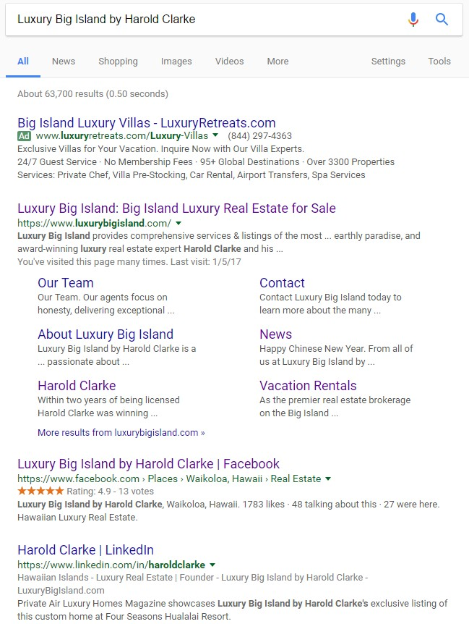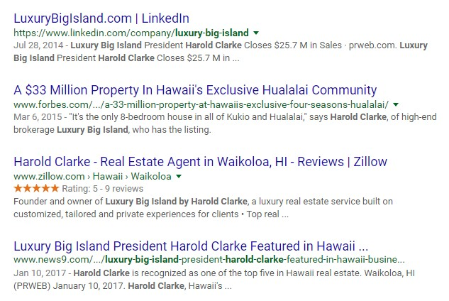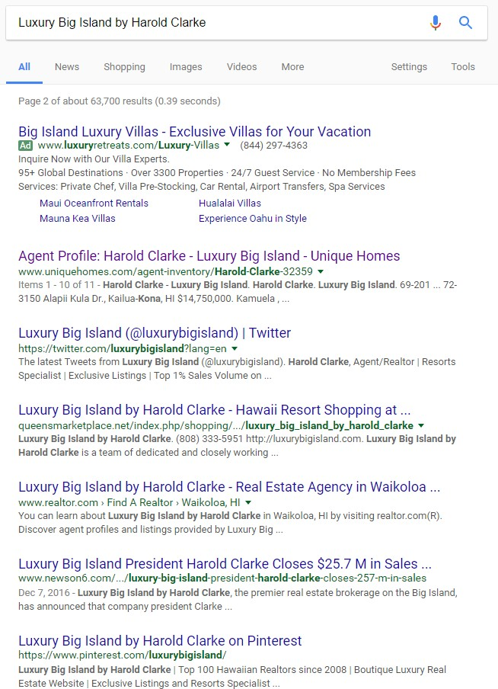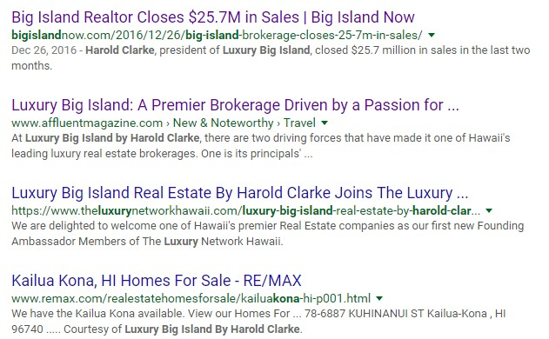

Media Summary

Publication | Link | Monthly  Circulation/UMV | Date
Press Release: Rare Luxury Real Estate Opportunity in Kukio: Fully Furnished Spec Home Listed for $14.75 Million
PR Web | https://goo.gl/wyl02v | 1,000,000 | 2/10/2017
Pitch Effort: Kukio Market Snapshot
PacificBusinessNews.com | https://goo.gl/c8t61D | 43,132 | 1/25/2017
Pacific Business News Eblast | email | 13,000 | 1/26/2017
Feature Articles: Harold Clarke
HuffingtonPost.com | https://goo.gl/Kmofye | 22,865,758 | 1/18/2017
Press Release: Luxury Big Island President Harold Clarke Featured in Hawaii Business Magazine's 2016 Black Book
PR Web | https://goo.gl/rtRB1r | 1,000,000 | 1/10/2017
Press Release: Luxury Big Island President Harold Clarke Closes $25.7 M in Sales
PR Web | https://goo.gl/EcY9bl | 1,000,000 | 12/7/2016
Big Island Now | https://goo.gl/4M0CR8 | 52,073 | 12/26/2016

Link to all media placements: https://goo.gl/hTfSpQ


Timeline: March

Draft and distribute one news item; topic TBD

- Further develop media invites for real estate tour; begin outreach

- Active ongoing pitching to secure media placements tied to real estate industry, trends, Kukio MB23

- Monitor subscription-based media queries (HARO, ProfNet) for relevant opportunities and pitch Harold Clarke as a source for expert commentary, as appropriate

- Monitor news and trends that impact the luxury real estate market in Hawaii

- Provide monthly reporting

- Ongoing coordination with Greybox

